Unit 2 I’m going to be a driver
A 图文配对
policeman，doctor，teacher，taxi driver, nurse

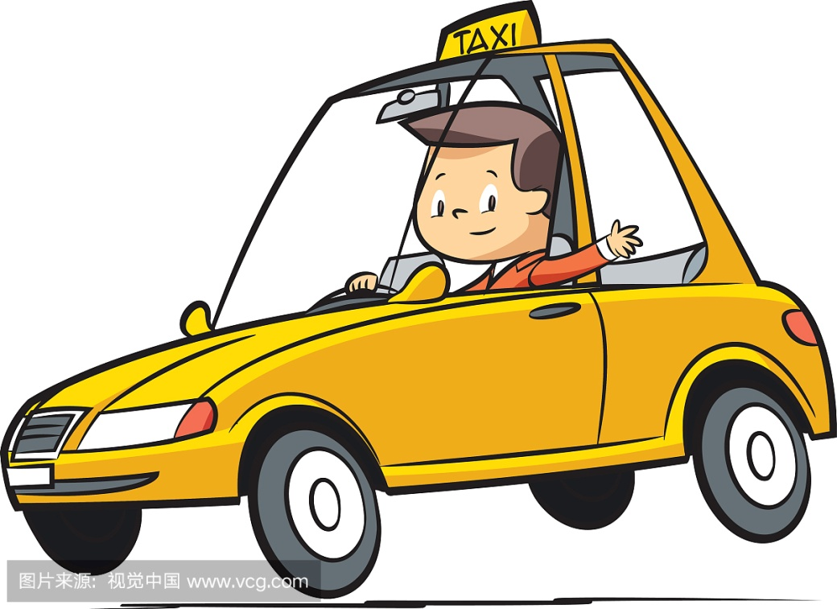
----------------------------------------------------------------------------------------------------------------------------------------------------------------
---------------------------------------------------------------------------------------------------------------------
------------------------------------------------------------------------------------------------------------------------

--------------------------------------------------------------------------------------------------------------------------
------------------------------------------------------------------------------------------------------------------------

、
B,判断正误，正确的写T，错误的写F。
( ) 1, This is my mother. She is a nurse .
( ) 2, She is a policeman .
( ) 3, I am going to be a bus driver .
( ) 4, I'm going to be a good teacher .
将您的全家福贴在方框内，尝试介绍你的家人。
Look at the photo , The man is my dad. He is a _________ .The beautiful woman is my mum .She is a ___________ . ________________________________.The boy/girl is me .I am a _______ .I am going to be a __________ .

