Module 8 Unit 2 Sam is going to ride a horse

words box:
visit tigers, take some pictures, see some lions, visit birds, visit monkeys…

Name:

…
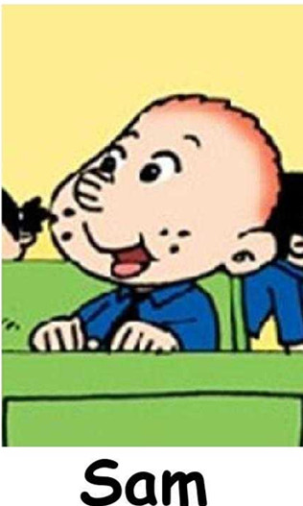
is/ are going to …

