**Unit9 Can you come to my party?(Grammar)**

**一.如何表达邀请学科网(www.zxxk.com)--教育资源门户，提供试卷、教案、课件、论文、素材及各类教学资源下载，还有大量而丰富的教学相关资讯！与答复别人的邀请**：

1. can 用于表示 “____________”，如：

汤姆会骑马。 ___________________

2. “Can you…?”表达 “______________”，

答语：同意用____________________.

不同意用__________________________.

如：恐怕不行，我要去探望我的姑姑。

____________________________________

**二、学生阅读Grammar Focus中的句子，然后做填空练习。**

① ─星期六你能来我的聚会吗？

─____ you ___学科网(www.zxxk.com)--教育资源门户，提供试卷、教案、课件、论文、素材及各类教学资源下载，还有大量而丰富的教学相关资讯！__ to my party on Saturday?

─当然，我乐意来。Sure. ____ _____ _____.

─对不起，我必须为数学考试而学习。

Sorry, I _____ _____ _____ a math test.

② ─ 明天晚上你能去看影剧院吗？

─ _____ you ____ to the movie ___________ night?

─当然可以，听起来很棒。

─ ______, that _______ ________.

─ 恐怕不行，我得了流感。

─ I’m ______ not. I have the ______.

③ ─ 他能去聚会吗？

─ _____ he ______ to the party？

─ 不能。他必须帮助他的父母亲。

─ No, he ____. He _____ to help his parents.

④ ─ 她能参加棒球比赛吗？

─ ____ she go to the baseball _______?

─ 不，她没有空。她必须去看医生。

─ No, she’s _______ ________. She ______ to ____ to the ______.

⑤ ─ 他们能去看电影吗？

─ _____ they____ to the _______？

─ 不，他们没有空。他们可能必须去见朋友。

─ No, they’re not __________. They _____ ______ ____ meet their ________.

**三**、

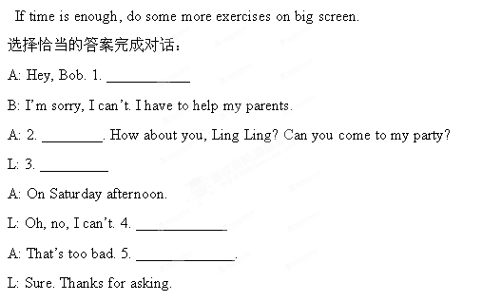

A. That’s too bad. B. Can you come to my party?

C. Are you going shopping with me?

D. Maybe another time. E. I have to study for a test.

F. When is it? G. I’d love to.

A. That’s too bad. B. Can you come to my party?

C. Are you going shopping with me?

D. Maybe another time. E. I have to study for a test.

F. When is it? G. I’d love to.

A. That’s too bad. B. Can you come to my party?

C. Are you going shopping with me?

D. Maybe another time. E. I have to study for a test.

F. When is it? G. I’d love to.