练习五

一、读一读，填一填、标四声。

y + i ( ) 

w + u ( )

y + ü ( )

1. 写出下列拼音中的整体认读音节。

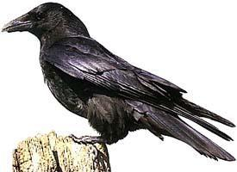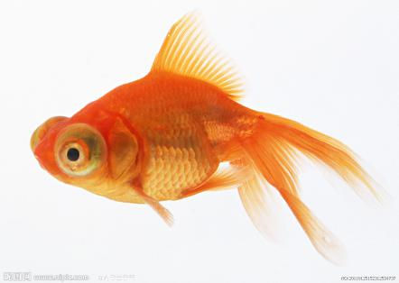****

（ ） yā xiǎo （ ） （ ） fú

1. 读一读，描一描。

 + = + =





+ =

|  |  |  |  |  |  |  |  |  |  |
| --- | --- | --- | --- | --- | --- | --- | --- | --- | --- |
| yī  yí  yǐ  yì |  |  |  |  | wú |  |  |  |  |
|  |  |  |  |  |  | wū |  |  |  |
|  |  |  |  |  |  |  |  |  |  |

wù

yū

yú

yǔ

yù

|  |  |  |  |  |  |  |
| --- | --- | --- | --- | --- | --- | --- |
|  |  |  |  |  |  | wǔ |
|  |  |  |  |  |  |  |
|  |  |  |  |  |  |  |

wū

wú

wǔ

wù

wū

wú

wǔ

wù

wū

wú

wǔ

wù