**一、Read and match.**

**Come on!**

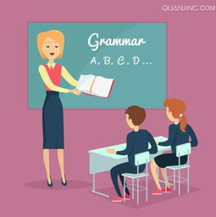 **a drive**

  **a teacher**

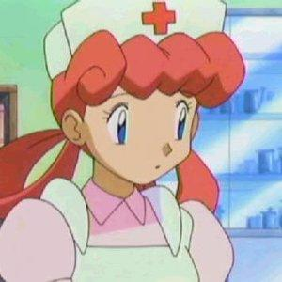 **a doctor**

**She’s**

**a farmer**



**a policeman**

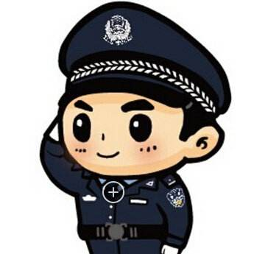 **a nurse**

**二、Who are you want to be? A teacher? A policeman?**

**Or something else? Please write down your answer,**

**and Draw a picture.**