指示代词（this/these/that/those）相关练习题

**1. Is this her ruler? Yes, it is. No, it isn’t**

**2. Is that Eric’s schoolbag? Yes, it is. No, it isn’t**

**3. Are these his pencils? Yes, they are. No, they aren’t**

**4. Are those Anna’s books? Yes, they are. No, they aren’t**

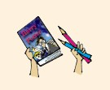

Is this your book?

Are these her pencils?

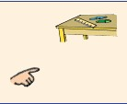

Are those his pens?

Is that Anna’s ruler?