**M8U1习题设计**

**一．选词填空**

**in on under**

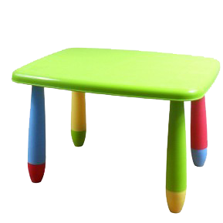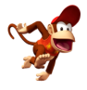

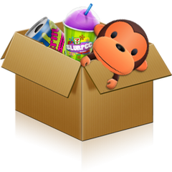**1. It’s_____ the desk.**

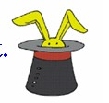**2. The monkey is _____the box.**

**3. It’s ＿＿ the hat.**

**4. It’s ＿＿ the chair**.

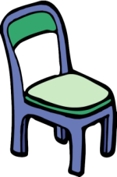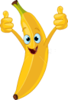

**二．看图回答问题**

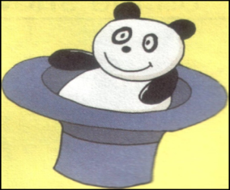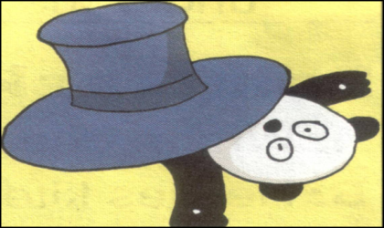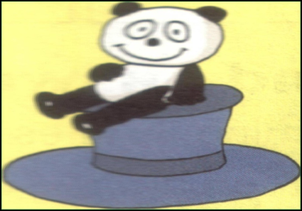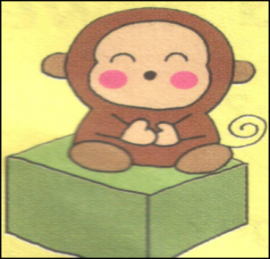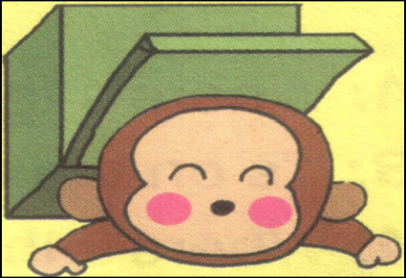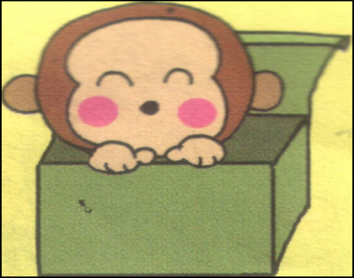

**Where is the ___?**

**It’s___ the ___.**