Handout

**Activity 1. Matching games**

|  |  |  |  |
| --- | --- | --- | --- |
| （1） | | （2） | |
| ham | ①菠萝 | ①几乎不adv. | ① shameful/shameless |
| ② pine | ②鸡蛋 | ②想家的adj. | ② US(United States) |
| ③ apple | ③汉堡 | ③晕家的adj. | ③ IT(Information Technology) |
| ④ egg | ④火腿 | ④可耻的adj. | ④ homesick |
| ⑤ hamburger | ⑤松树 | ⑤世卫组织 | ⑤WHO |
| ⑥ pineapple | ⑥苹果 | ⑥美国 | （World Health Organization） |
| ⑦ eggplant | ⑦茄子 | ⑦信息技术 | ⑥ hardly |

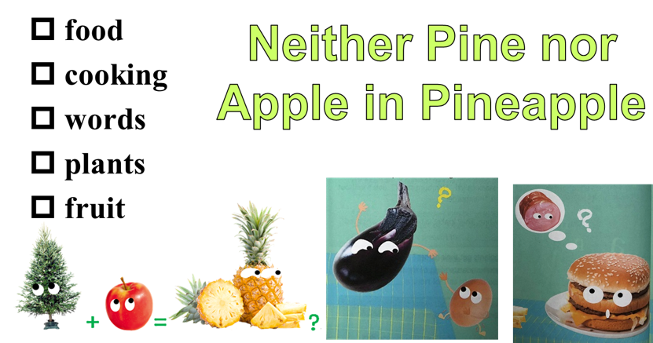

**Activity 2. Guessing. (P18)**

Tick one word for the passage.

**Activity 3. Why did the author write this passage?**

①To tell that English is very difficult to learn.

②To give advice on how to learn English.

③To show that English is interesting and creative.

④To explain how English was created.

**Activity 4. Structure**

1. topic sentence(in para.1)?
2. the structure of the passage

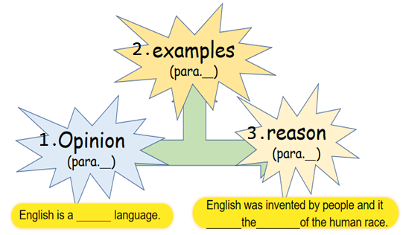

**Activity 5. Examples**

1. Complete the notes
2. 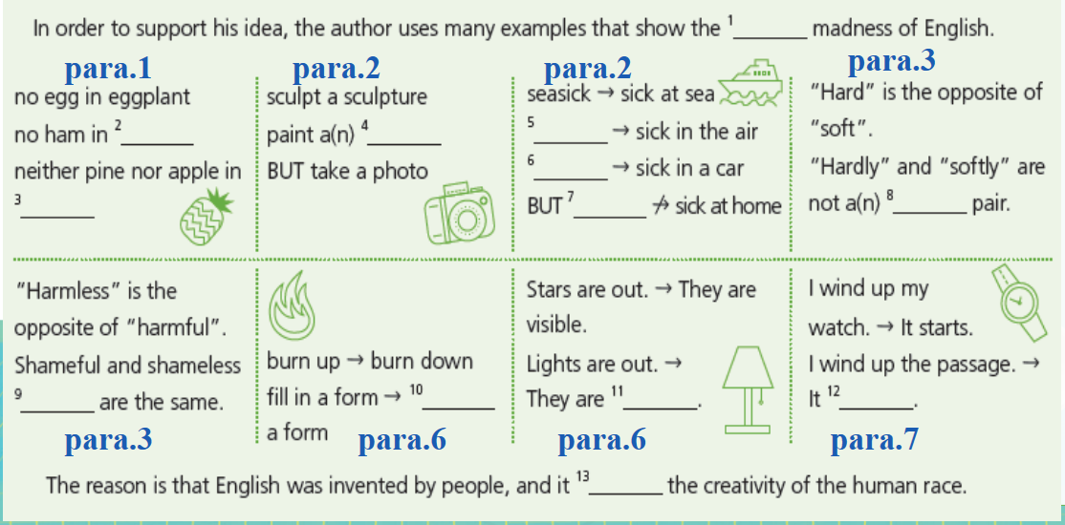Match the correct findings.

Pair 4

Pair 2

Pair 3

Pair 1

**(Matching)**

|  |  |
| --- | --- |
| Pair 1 | 1. One rule can’t be used for everyhing! |
| Pair 2 | B．The same words 🡪 different meanings! |
| Pair 3 | C. 1 and 1 don’t always make 2! |
| Pair 4 | D. Different words 🡪 the same meaning! |

**Activity 6. Think about more examples (both English and Chinese)**

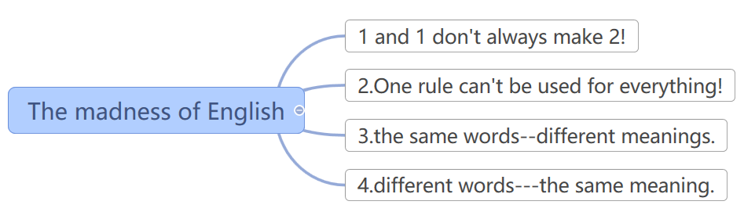

moon+cake≠mooncake

go to school but go home

play the guitar vs. play tennis

see a movie=watch a movie

**Homework:**

1. Write down more examples for each type of findings.

2. Review the structure and the findings to prepare for retelling( telling the passage again on your own ) next time.